**ACH payment processing application**

Contents

Introduction 3

General Requirements for this application 3

Technical Details 4

Appendix – A 6

# Introduction

This application will work as a middleware payment processing application for JMGrove existing websites or any future website which will need payment integration.

It will process ACH payments for customers and will need ACH payment processor to integrate in application along with reporting capabilities.

Application will mainly process Recurring & One time ACH payment.

# General Requirements for this application

As this is payment processing application, high availability and accuracy is must. Please make sure that practices given below must be followed.

1. Maintain high accuracy in calculation and conversion of datatypes related to money.
2. Create a common decimal places price round up method in shared location and use same method throughout application in order to avoid different prices at different level of application stage. For example on payment page $800.50 and on Invoice page $801.
3. Follow proper exception handling while communicating with payment processing gateway and consider all possible failure situation while receiving response from payment processing company. Refer payment processor company’s API documents thoroughly for better integration.
4. Use transactions while updating price sensitive information in multiple price related tables of database in order to avoid inconsistent data in database.
5. Properly comment method and code with complex logic written into it, so other developer in team need less amount of time to understand while working on it.
6. Update UI with proper user friendly messages to provide better understanding and user experience to the user of application.
7. Do proper Unit testing of module as per the analysis document before handed over to review.
8. If possible use bootstrap for consistent and optimized UI.
9. Evaluate each module in application and provide proper estimate of development effort with due date.

# Technical Details

Screen 1: Create page with tab interface to take input from customer about their billing & payment related details.

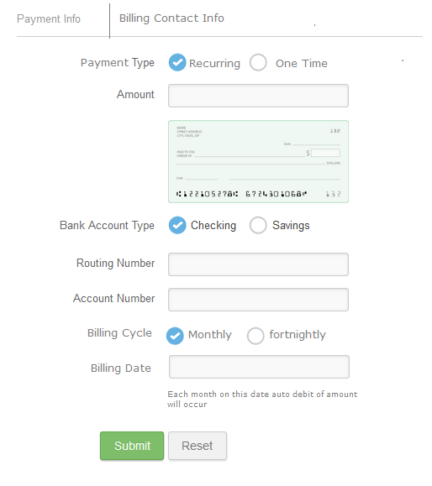

On submit button capture information into database and move screen to next tab, “ Billing Contact Info”

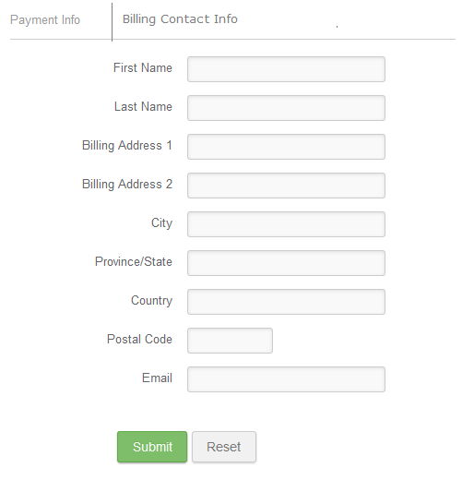

On submit button capture this detail and submit this details to database. After that take payment details and billing information to payment processing company and make a call to process payment. Based on call result to payment processor update user with status message of Success or Failure with proper user friendly error message.

Note: Create payment processor specific code into generic method or create console application for output of dll file and make use of that.

Reason to do so is, that core component can be used in any mechanism like we create page and accept payment or we crate rest api and accept payment and billing information details and process payment with response returned as a status code.

# Appendix – A

ACH payment processing companies which we can use to integrate in our ACH payment processing application.

|  |  |
| --- | --- |
| **SR#** | **URL of ACH payment processor website** |
| 1 | <https://www.bluepay.com> |
| 2 | <https://www.forte.net/ach-processing> |
| 3 | <https://www.firstach.com/front/index.html> |
| 4 | <https://paysimple.com/ach_merchant_account.html> |